LAB - Consumir servicios REST

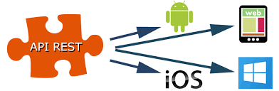

Objetivos

* Consumir servicios API Rest desde iOS
* Configurar permisos info.plist
* Uso de Librerías swiftJSON Alomafire

Preparar proyecto base:

Abrir el proyecto

Install Node JS:

<https://nodejs.org/en/download/>

Version of Swift

xcrun swift --version

URL Alomafire

<https://github.com/Alamofire/Alamofire/tree/3.0.1>

URL SwiftJSON

<https://github.com/SwiftyJSON/SwiftyJSON>

Update Podfile:

# Pods for FoodTracker

pod 'RealmSwift'

pod 'Alamofire', '~> 4.5'

pod 'SwiftyJSON'

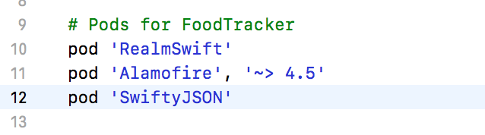

## Test de coneccion a REST/API

Create new ViewController and create relation ship segue with tab Bar:

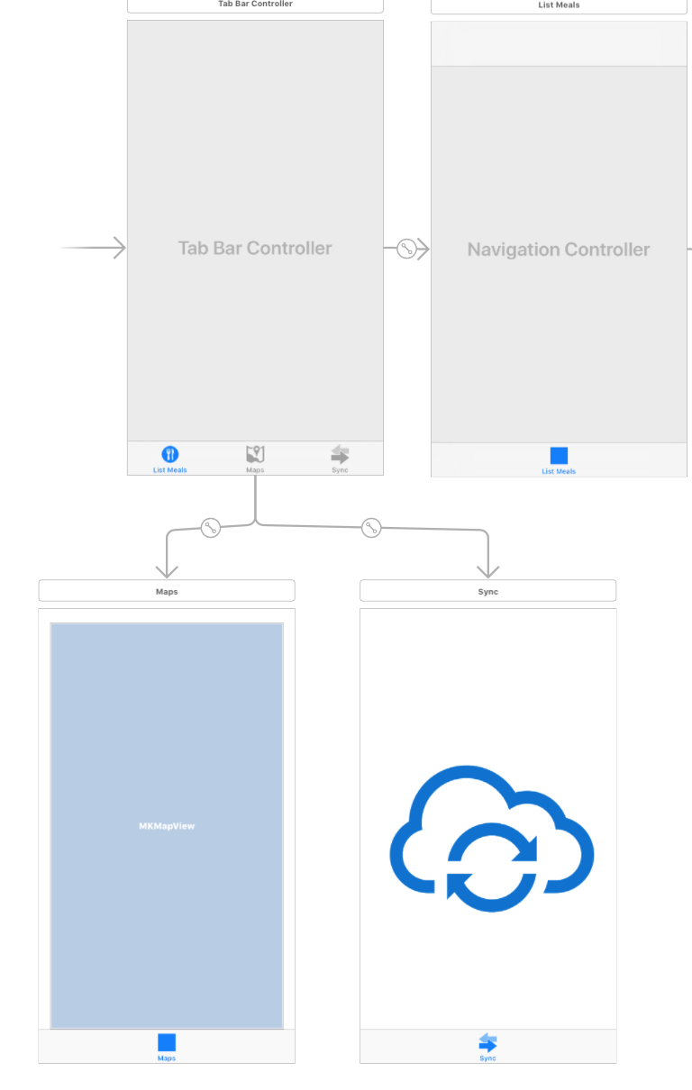

Put a button and center:

Create @IBAction startSync in the SyncController class

in the click button implement following line:

@IBAction func startSync(_ sender: UIButton) {

// GET

Alamofire.request("https://ios-course-5279a.firebaseio.com/user.json", method: .get).responseJSON { response in

print("Request: \(String(describing: response.request))") // original url request

print("Response: \(String(describing: response.response))") // http url response

print("Result: \(response.result)") // response serialization result

if let json = response.result.value {

print("JSON: \(json)") // serialized json response

}

if let data = response.data, let utf8Text = String(data: data, encoding: .utf8) {

print("Data: \(utf8Text)") // original server data as UTF8 string

let json = try! JSON(data: data)

print("the length \(json.count)")

print("the data is \(json["-KzG-ecZgoksJNxiO7C2"]["ci"])")

for (key,subJson):(String, JSON) in json {

// Do something you want

print("the key is ---> \(key) the value is \(subJson)")

}

}

}

// POST

let parameters: Parameters = [

"ci": 66666,

"userName": "JHONNY VILLARROEL"

]

Alamofire.request("https://ios-course-5279a.firebaseio.com/user.json", method: .post, parameters: parameters, encoding: JSONEncoding.default)

// DELETE

Alamofire.request("https://ios-course-5279a.firebaseio.com/user/-KyhBjRdH6MBRORHY7ic.json", method: .delete)

// UPDATE or PATCH

let paramsUpdate:Parameters = [

"ci": 8888888

]

Alamofire.request("https://ios-course-5279a.firebaseio.com/user/-KzFqQfy64S3WHEuw6pD.json", method: .patch,parameters:paramsUpdate, encoding: JSONEncoding.default)

}

## Configure insecure service (No HTTPS):

Agregar la siguiente directiva para consumir rest que no tienen HTTPS configurado

* Abrir info.plist como codigo y agregar las siguientes lineas

<key>NSAppTransportSecurity</key>

<dict> <!--Include to allow all connections (DANGER)--> <key>NSAllowsArbitraryLoads</key>

<true/>

</dict>